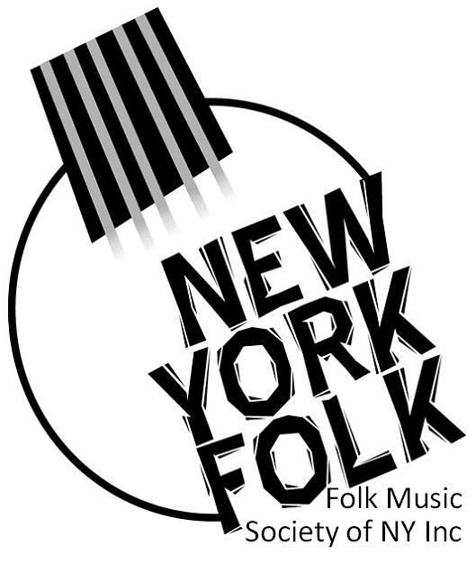

The Folk Music Society of New York presents
Sara Gray and Will Brown in a Live, Online Concert
Friday, November 27, 2020, 7:30 PM
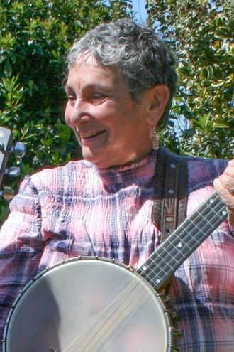
Sara Gray and Will Brown, two of Maine’s most revered folk performers, are teaming up to deliver an exciting night of folk music magic on Friday, November 27th.
Sara, who, was born and raised in New Hampshire, has lived in various parts of the states and in England and Scotland, and has absorbed musical traditions from everywhere she’s lived. Sara is known for her beautiful voice, her forthright delivery, and her driving banjo accompaniment.
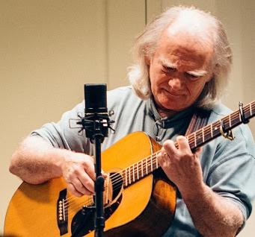
Will is known for his finger style guitar, and also plays the bouzouki and oud. He has played with and recorded with many well known Maine musicians, including Gordon Bok, Cindy Kallet, Grey Larsen, Anne and David Dodson, George Fowler. Will’s arrangement of the U. Utah Phillips song “Going Away” is included in the Grammy-nominated compilation, “Singing Through the Hard Times”.
Minimum Contribution: $5.00. Tickets available online at https://saragrey.eventbrite.com .
Information: 646-628-4604.

--- ### ---
Pictures are available at: http://www.folkmuiscny.org/press. Members of the press are always welcome at our events and tear sheets are appreciated.
Press contact: Heather Wood, 646-628-4604, or publicity@folkmusicny.org, for further information or to receive releases by e-mail in the future.
The Folk Music Society of New York, Inc. / New York Pinewoods Folk Music Club is a non-profit 501(c)(3) educational corporation, and an affiliate of the Country Dance and Song Society of America. It is run by a volunteer Board of Directors, elected by the membership. It runs concerts, weekends, classes, singing parties, and get-togethers, all with an emphasis on traditional folk music of all flavors.

